Experiment 2: Effect of Temperature on Enzyme Activity
Data Tables and Post-Lab Assessment
Table 2: Balloon Circumference vs. Temperature
Tube | Temperature (°C) | Balloon Circumference (Uninflated; cm) | Balloon Circumference (Final; cm)
1 – (Cold) | 8 | 6 | 11
2 – (RT) | 24 | 6 | 16
3 – (Hot) | 85 | 6 | 25

Post-Lab Questions
- What reaction is being catalyzed in this experiment?
  - The hydrogen peroxide is being catalyzed by the catalase in the yeast creating hydrogen and water.

- What is the enzyme in this experiment? What is the substrate?

  - The enzyme in this experiment is the catalayse, carbohydrate, that is found in the yeast and the substrate is the hydrogen peroxide. The carbohydrates may work here as substrate and invertase enzyme may be produced by yeast.

- How does the temperature affect enzyme function?
  - The temperature did not affect the enzyme function, because all the balloons increased in size, due to the yeast reacting with the peroxide.

- Draw a graph of balloon diameter vs. temperature. What is the correlation?
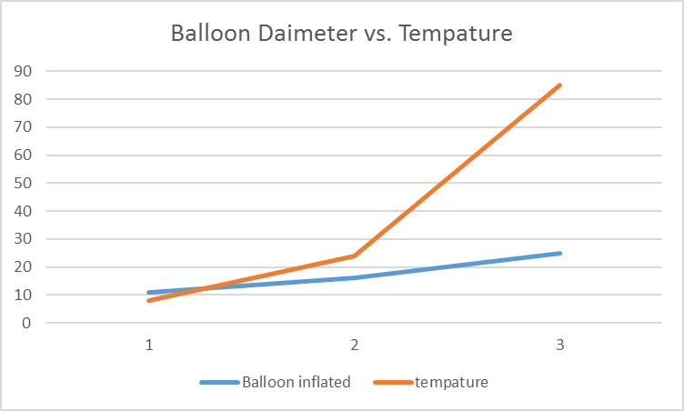

  - The graph shows that as temperature rises, the balloon circumference increases also.

- Is there a limit to enzyme rate? Explain your response with scientific evidence.

- Do bacteria have an enzyme that breaks down hydrogen peroxide? How could you test this?

- How can enzyme activity be increased?

  - One way to increase the activity of an enzyme is to alter the temperature, to bring it nearer to the optimum for that enzyme. Another is to adjust the pH, likewise to approach the optimum. If there is very little of the enzyme present, increasing the enzyme concentration will also accelerate the overall process.

- Design an experiment to determine the optimal temperature for enzyme function, complete with controls. Where would you find the enzymes for this experiment? What substrate would you use?
  - Using Fleishmann’s Yeast will provide the enzymes and hydrogen peroxide will serve as the substrate.
  - Place the substrate and enzyme in a test tube
  - Allow for the reaction to begin
  - Place the tube in a beaker with room temperature water
  - Then place the beaker on the stove
  - Place a thermometer inside the beaker
  - Begin recording the temperature of the reaction
  - Measure the concentration of the sample and correlate it with each temperature reading
  - The point at which the reaction is most concentrated is the optimum temperature.

  - It could be performed by taking pepsin enzyme from the lab. The protein supplement could be used as the substrate and then water could be used as a control. Once the temperature condition increases then its reactivity increases. After getting its optimum temperature, it shows maximum activity while, then increment in temperature may destroy it.

- Hydrogen peroxide is toxic to cells, yet is a common byproduct of the reactions that occur inside the body. How can this compound be changed to become non-toxic (Hint: Look at the chemical formula of hydrogen peroxide).
  - Hydrogen peroxide may be broken by enzyme catalase into water and oxygen hence; its toxicity could be overcome.

- Identify the enzyme used in your experiment. Identify the substrate.
  - The enzyme in this experiment is the catalayse, carbohydrate, that is found in the yeast and the substrate is the hydrogen peroxide. The carbohydrates may work here as substrate and invertase enzyme may be produced by yeast.

- In general, how would an increase in substrate alter enzyme activity? Draw a graph to illustrate this relationship.

  - The increase would reach a peak and even out and then decrease.

